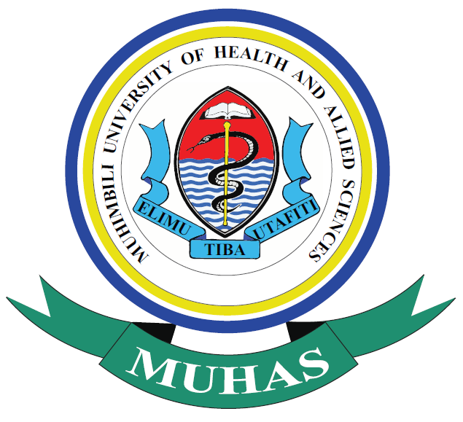
MUHIMBILI UNIVERSITY OF HEALTH AND ALLIED SCIENCES (MUHAS) SCHOOL OF DENTISTRY
DEPARTMENT OF RESTORATIVE DENTISTRY
Operative Dentistry Unit (ODU)

University Dental Clinic C L E R K S H I P 1a-5
(Restorative) Ac. yr: ___ - ____
MDent RD ( 1 2 3 ) encircle Student ______________ Scan: ___
Module: OD 601, ..2, ..3, ..4, ..5, ..6 encircle Date: …../…../20…..
CLINICAL RESTORATIVE DENTISTRY

PATIENT GENERAL INFORMATION AND ANAMNESIS

Name: ………………………………… Hosp. Reg. No. ………….…… Sex: m / f Age: ……. yrs
1 Married, 2 Single, 3 Divorced [ ] Tribe/Nation:……..……..…..… Occup.……………………..…
Contact Tel. ……….…………. Physical Address: P. O. Box ….……. Street ………... House No: …
Area/Ward: ……………………….… Town/Municipality/City: …………….………….……….

Patient’s Chief Complaint: - …………………………….…………………………………...
Past Dental History
- Fist attendance (encircle number or tick in box): yes [ ] , no [ ]
- Previous attendance and reason (encircle number/fill)
1 Dental check-up 2 Extraction 3 Scaling 4 Restoration 5 Prosthesis
6 Others: ……………………………………… Vital Signs: BP ___ / __ Pulse ___
Complication after treatment (if any): …………………….………………………....................
- Precautions (if any): ……………………………………………………………….……………...

Presenting Dental History (encircle number or tick in box)
- Signs, symptoms
- Pain: Absent ( ), Present ( ),
Onset: 1 spontaneous, 2 non-spontaneous
Severity: 1 mild, 2 moderate, 3 severe
Character: 1 localized, 2 not localized
Quality: 1 dull, 2 burning, 3 sharp, 4 throbbing
Duration: 1 few min. after stimulus removal, 2 several min. > an hour
Radiation: 1 yes, 2 no
Aggravating factors: 1 chewing, 2 hot, 3 cold, 4 salty, 5 sweet
Relieving factors: 1 mild analgesics, 2 strong analgesics, 3 Others: ………………..
- Cavity/caries [ ] 3 Swelling [ ] 4 Pus discharge/fistula [ ] 5 Halitosis [ ] 6 Bleeding gums [ ]
7 Loose denture [ ] 8 Ulceration [ ]; 9 Others(specify):…………., ………………, …………

Medical history
- History (if present)of:
1 Diabetes [ ] 2 BP[ ] 3 Asthma[ ] 4 Allergies [ ] 5 Heart [ ] 6 Major surgeries [ ] 7 Pregnancy[ ]
(7.1= 1st trimester, 7.2=2nd trimester, 7.3=3rd trimester); 8 HIV/AIDS; 9 Others(specify): ………….
- Medication: Type & dosage of drug(s) in use (if any): ……………………………………..
RD-ODU MDentRD,ClinRxForm01-Ver 20, 2025.11.13

University Dental Clinic (Restorative) 1b-5
MDent RD ( 1 2 3 ) encircle Student ___________ Scan: ___
Module: OD 601, ..2, ..3, ..4, ..5, ..6 encircle Date: …../…../20…..

Health/Clinical Examination (encircle/fill)
- General: A. Healthy looking; B. Ill-looking; C. Pulse:… r/min; D. BP:....../…… mm/Hq.
E. Others(specify): …………………………………………………………………
- Review of Other Systems: …………………………………………………………………
- Local: Extra-oral A. Facial symmetry:- 1 ok, 2 not Ok
B. TMJ: 1 tenderness, 2 sounds, 3 jaw deviation, 4 restricted movement
C. Lymph node:- 1 palpable, 2 not palpable
D. Lip competence:- 1 competent, 2 incompetent
Intra-oral
A. Soft tissue:- 1 normal, 2 abnormal (specify) …………………………………...
B. Deposits:- 1 plague (Sextant I, II, III, IV, V, VI); 2 calculus (Sextant I, II, III, IV, V, VI)
C. Bone (topographic):- 1 normal 2 abnormal (specify) …..……………………....
D. Occlusion:- 1 normal 2 malocclusion (specify) ………………………………..
E. Prosthesis:- 1 absent 2 present (type, status –explain: …..……………………..
F. Dentition:- Tooth: 1/NE not erupted, 2/X missing, 3/#; Surface: 4 decayed, 5 filled &Ok,
6 filled with 2º caries, 7 filled- defective, 8 wear, 9 discoloured, 8 other ……. DMFT: … --- R E M A R K S ---
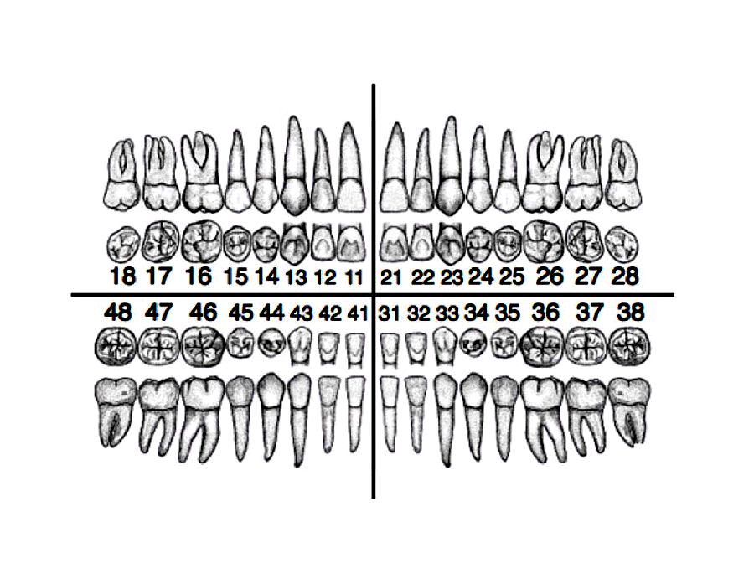
Description ______________________________________________________________________________
_____________________________________________________________________________________
_____________________________________________________________________________________

Impression(s): 1________________ 2________________ 3_______________ 4 __________________
Investigations (if any) Report:
_________________________ ______________________________________________________
_________________________ ______________________________________________________
Working Diagnose(s): 1_________________ 2_________________ 3____________________
Problem List 1. ……………… 2. ……………..… 3……………… 4. ……………...… 5 …………………

General Treatment Plan (Medical-Dental), Comprehensive & Sequenced
1____________________ 2___________________ 3___________________ 4____________________

Consultation(encircle): 1 Med/Surg 2 Oral surgery 3 Ortho/Pedo 4 Operative 5 Perio 6 Prostho
Checked/Accepted ……………………………… (Sign) Date: ___/ ___/20___

University Dental Clinic (Restorative) 2a-5
MDent RD ( 1 2 3 ) circle Student ___________ Scan: ___
Module: OD 601, ..2, ..3, ..4, ..5, ..6 circle Date: …../…../20…..

OPERATIVE CARE
Treatment Plan
([C]ons, [V]eneer, [Cr]own, [B]ridge, [E]ndo) sequenced

S/n T(s) Patho Inv(s) Working Diag C/V/Cr/B/E C-size R_{x} outline (tech/cosm/clns-clbf) Date [Qnty/Issued]
1) ..…… …….. …… ………….. ………... s m l Pt/RCT/ ART/ C on …….……. .../… [… ……......]
2) ..…… …….. …… ………….. ………... s m l Pt/RCT/ ART/ C on …….……. .../… [… ……......]
3) ..…… …….. …… ………….. ………... s m l Pt/RCT/ ART/ C on …….……. .../… [… ……......]
4) ..…… …….. …… ………….. ………... s m l Pt/RCT/ ART/ C on …….……. .../… [… ……......]
5) ..…… …….. …… ………….. ………... s m l Pt/RCT/ ART/ C on …….……. .../… [… ……......]
Other types of treatment required: _____________________________________________________

Plan Accepted _______________ (Instructor) Date: …./ …./20….

Treatment
1: Conservative Treatment (cons) Comprehensive [ ]; Discrete [ ]

- Direct Restorations
EPLRF system" = Excavation, Preparation, Liner-matrix, Restoration, and Finishing. Dent (Tooth)
Score: Completed with: Full help (Poor= 1) ; Much help (Satisfactory=2); Little help (Good=3), No help (Very good=4), (Excellent=5)

- Metal 1 2
Operator ID:___ (80%), Assistant ID:___ (20%) Operator ID:___ (80%), Assistant ID:___ (20%)
procedure D:___ Sf:___ Clns:__ Mat:___ procedure D:___ Sf:___ Clns:__ Mat:___
Score Date Sign +Remark Score Date Sign +Remark

a) Fx property 1 2 3 4 __/____ ________________ a) Fx property 1 2 3 4 ___/___ _________________

b) Bio property 1 2 3 4 __/____ ________________ b) Bio property 1 2 3 4 ___/___ _________________

c) Color match 1 2 3 4 __/___ ________________ c) Color match 1 2 3 4 ___/___ _________________

d) Restoration 1 2 3 4 __/____ ________________ d) Restoration 1 2 3 4 ___/___ _________________

e) Finishing 1 2 3 4 __/____ ________________ e) Finishing 1 2 3 4 ___/___ _________________
Total points out of 20 = __ ( __%) Total points out of 20 = __ ( __%)
- Gold 1 2
Operator ID:___ (80%), Assistant ID:___ (20%) Operator ID:___ (80%), Assistant ID:___ (20%)
procedure D:___ Sf:___ Clns:__ Mat:___ procedure D:___ Sf:___ Clns:__ Mat:___
Score Date Sign +Remark Score Date Sign +Remark

a) Fx property 1 2 3 4 __/____ ________________ a) Fx property 1 2 3 4 ___/___ _________________

b) Bio property 1 2 3 4 __/___ ________________ b) Bio property 1 2 3 4 ___/___ _________________

c) Color match 1 2 3 4 __/___ ________________ c) Color match 1 2 3 4 ___/___ _________________

d) Restoration 1 2 3 4 ___/___ ________________ d) Restoration 1 2 3 4 ___/___ _________________

e) Finishing 1 2 3 4 ___/___ ________________ e) Finishing 1 2 3 4 ___/___ _________________
Total points out of 20 = __ ( __%) Total points out of 20 = __ ( __%)
- Tooth coloured 1 2
Operator ID:___ (80%), Assistant ID:___ (20%) Operator ID:___ (80%), Assistant ID:___ (20%)
procedure D:___ Sf:___ Clns:__ Mat:___ procedure D:___ Sf:___ Clns:__ Mat:___
Score Date Sign +Remark Score Date Sign +Remark

a) Fx property 1 2 3 4 __/____ ________________ a) Fx property 1 2 3 4 ___/___ _________________

b) Bio property 1 2 3 4 __/___ ________________ b) Bio property 1 2 3 4 ___/___ _________________

c) Color match 1 2 3 4 __/___ ________________ c) Color match 1 2 3 4 ___/___ _________________

d) Restoration 1 2 3 4 ___/___ ________________ d) Restoration 1 2 3 4 ___/___ _________________

e) Finishing 1 2 3 4 ___/___ ________________ e) Finishing 1 2 3 4 ___/___ _________________
Total points out of 20 = __ ( __%) Total points out of 20 = __ ( __%)
- Tooth coloured 3 4
Operator ID:___ (80%), Assistant ID:___ (20%) Operator ID:___ (80%), Assistant ID:___ (20%)
procedure D:___ Sf:___ Clns:__ Mat:___ procedure D:___ Sf:___ Clns:__ Mat:___
Score Date Sign +Remark Score Date Sign +Remark

a) Fx property 1 2 3 4 __/____ ________________ a) Fx property 1 2 3 4 ___/___ _________________

b) Bio property 1 2 3 4 __/___ ________________ b) Bio property 1 2 3 4 ___/___ _________________

c) Color match 1 2 3 4 __/___ ________________ c) Color match 1 2 3 4 ___/___ _________________

d) Restoration 1 2 3 4 ___/___ ________________ d) Restoration 1 2 3 4 ___/___ _________________

e) Finishing 1 2 3 4 ___/___ ________________ e) Finishing 1 2 3 4 ___/___ _________________
Total points out of 20 = __ ( __%) Total points out of 20 = __ ( __%)

B) Indirect Restorations
- Inlay (1) / Onlay (2) [__] Rx Score (encircle) Instructor
- Tooth no……... 1 2 3 4 5 _____________
- Tooth preparation 1 2 3 4 5 _____________
- Material selection: Compo/Ceramic/Agm/Gold/CAD-CAM block 1 2 3 4 5 _____________
- Tech: Lab/Chairside 1 2 3 4 5 _____________
- Cementation and finishing 1 2 3 4 5 _____________
Materials:
Temporary: ……………, …………, ……….., :
Permanent: Centrion, Metal (Amalgam, Gold, Chrome,…….),
Tooth colored (Composite, GIC, Cention-N).
2: Veneer (Ven)

- Direct veneer
Operator ID:___ (80%), Assistant ID:___ (20%) Operator ID:___ (80%), Assistant ID:___ (20%)
procedure D:___ Sf:___ Clns:__ Mat:___ procedure D:___ Sf:___ Clns:__ Mat:___
Score Date Sign +Remark Score Date Sign +Remark

a) Mat. selection 1 2 3 4 ___/___ __________________ a) Preparation 1 2 3 4 ___/___ ___________________

b) Preparation 1 2 3 4 ___/___ __________________ b) Post material 1 2 3 4 ___/___ ___________________

c) Mat. placement 1 2 3 4 ___/___ __________________ c) Post length 1 2 3 4 ___/___ ___________________

d) Restoration 1 2 3 4 ___/___ __________________ d) Core material 1 2 3 4 ___/___ ___________________

e) Finishing 1 2 3 4 ___/___ __________________ e) Retention 1 2 3 4 ___/___ ___________________
Total points out of 20 = __ ( __%) Total points out of 20 = __ ( __%)

Direct Veneer [__] Rx Score (encircle) Instructor
- Tooth preparation 1 2 3 4 5 _____________
- Material selection: Compo/Ceramic/Agm/Gold/CAD-CAM block 1 2 3 4 5 _____________
- Tech: Lab/Chairside 1 2 3 4 5 _____________
- Cementation and finishing (Color/shade/anatomical form) 1 2 3 4 5 _____________
Score:
Completed with: Full help (Poor= 1) ; Much help (Satisfactory=2); Little help (Good=3), No help (Very good=4), (Excellent=5)
Fx-functional property (material fracture, marginal adaptation, proximal contacts, form & contour, occlusion and wear). Bio-Biological property (caries at restoration margins, dental hard tissue defects at restoration margins, postoperative hypersensitivity and pulp status), Colour match (surface luster and texture, marginal staining and shade).

3: Bridges (Brg)

4: Other Operative Procedures

- Provided: __________________
__________________

Review of Treatment Plan: ___________________________________________________
University Dental Clinic (Restorative) 3a-5
MDent RD ( 1 2 3 ) encircle Patient’s name: ………………………….
Module: OD 601, -2, -3, -4, -5, -6 encircle Hosp. Reg. No. ………….
Student ____________ Scan: __
5: Endodontic Therapy (endo) Comprehensive [ ], Discrete [ ]
== DIAGNOSIS
Tooth No.: _______
History & Clinical Examination (Tick if present)
Caries  Enamel… Dentinal...  Pulp exposure...... |  |  | Trauma  Root # …...  Crown #..... | Treated  RCT… Filling… Capping….. Pulpotomy…. F. Dislodged …. |  |  |  |  |  |  | Tenderness |  |  | Swelling |  |  |  |  | Fistula |  | Tooth  mobility | 1
 |  |  |  |  |  |  |  |  |  |  |  |  |  |  |  |  |  |  |  |  |  | 2
 |  |  |  |  |  |  |  |  |  |  |  |  |  |  |  |  |  |  |  |  |  | 3
Dental pulp tests (Tick if positive, Cross if negative)
Percussion |  | Cold test |  |  | Heat test |  | EPT |  |  |  |  | Test cavity
Radiographic findings
Pulp chamber |  |  | Normal |  | Partially calcified |  |  |  |  | Internal resorption |  |  |  |  |  |  | External resorption
Root canals |  |  | Normal |  | Coronal calcification |  |  |  |  | Apical calcification
 |  |  | Straight |  | Curved (≤45°, ≥45°) |  |  |  |  | Wide
Periapical area |  |  | Normal |  | Radiolucent area |  |  |  |  | Radio-opac area |  |  |  |  |  |  | External resorption
Furcation area |  |  | Normal |  | Radiolucent area |  |  |  |  | Radio-opac area |  |  |  |  |  |  | External resorption
Diagnosis: __________________ Instructor (Sign.): ____________ Date:.…/…./20…
== TREATMENT
1st visit Date: __ /__ /20__ Treatment type: Pulpotomy (Emergency [ ], Elective) [ ], Pulpectomy [ ]
Reasons for emergency pulpotomy:_....................................................................................
Tooth length: _____(mm): PA x-ray [ y, n], Use of Apex locator [ y, n], Number of canals: _____
Canal (type, length) Single M D ML MB1 MB2 DB B P
MAF (Size/No) ______ ______ ______ ______ ______ ______ ______ _____ _____
Working length (mm) ______ ______ ______ ______ ______ ______ ______ _____ _____
Preparation technique: Conventional [_], Step-back [_], Step-down forward [_]; Irrigating agent: ________________
Dressing material: Eugenol [_]; Cresophane [_]; CPCP [_]; Other (specify): __________________________________
Obturation done [ y, n ]: Technique- ___________________________ Material- ______________________________
Restoration of Access cavity: ZOE/IRM [_], Amalgam [_], Composite resin [_], Glass ionomer [_], Other ______________
Problems encountered during management: _______________________________________________________________

Instructor (Sign.): _____________ Date:__/___/_____
2nd visit Date:__ _/___/___
Irrigating agent: _______________________________
Dressing material: Eugenol [_]; Cresophane [_]; CPCP [_]; Other (specify): __________________________________
Obturation done [ y, n ]: technique- ___________________________ material- _________________________
Restoration of Access cavity: ZOE/IRM [_], Amalgam [_], Composite resin [_], Glass ionomer [_], Other ______________
Problems encountered during management: _______________________________________________________________

Instructor (Sign.): _____________ Date:__/___/_____
3rd visit Date:__ _/___/___
Irrigating agent: _______________________________
Dressing material: Eugenol [_]; Cresophane [_]; CPCP [_]; Other (specify): __________________________________
Obturation done [ y, n ]: technique- ___________________________ material- _________________________
Restoration of Access cavity: ZOE/IRM [_], Amalgam [_], Composite resin [_], Glass ionomer [_], Other ______________
Problems encountered during management: _______________________________________________________________
FINAL SCORE:___%. Instructor (Sign.) ________________ Date:__/___/___
RD-ODU MDentRD,ClinRxForm01-Ver 20, 2025.11.13
University Dental Clinic (Restorative) 3b-5
MDent RD ( 1 2 3 ) encircle Patient’s name: ………………………….
Module: OD 601, -2, -3, -4, -5, -6 encircle Hosp. Reg. No. ………….
Student ____________ Scan: __
Endodontic Therapy (endo) Cont.

Tooth No.: _______

Periapical radiograph Report
-----------------------------------------------------------------------------------------------------------------------------------------------------------------------------------------------------------------------------------------------------------------------------------------------------------------------------------------------------------------------------------------------------------------------------------------------------------------------------------------------------------------------------------------------------------------------------------------------------------------------------------------------------------
-------------------------------------------------------------------------------------------------------------------------------
Other investigation:
------------------------------------------------------------------------------------------------------------------------------------------------------------------------------------------------------------------------------------------------------------------------------------------------------------------------------------------------------------------------------------------------------------------------------------------------------------------------------------------------------------------------------------------------------------------------------------------------------------------------------------------------------------------------------------------------------------------------------------------------------------------------------------------
Re-treatment
------------------------------------------------------------------------------------------------------------------------------------------------------------------------------------------------------------------------------------------------------------------------------------------------------------------------------------------------------------------------------------------------------------------------------------------------------------------------------------
Surgical Endodontics
---------------------------------------------------------------------------------------------------------------------------------------------------------------------------------------------------------------------------------------------------------------------------------------------------------------------------------------------------------------------------------------------
---------------------------------------------------------------------------------------------------------------------------------------------------------------------------------------------------------------------------------------------------------------------------------------------------------------------------------------------------------------------------------------------
RD-ODU MDentRD,ClinRxForm01-Ver 20, 2025.11.13
University Dental Clinic 6a-5
(Restorative)
MDentRD OD 601-6 Student ____________ Scan: __

CLINICAL RESTORATIVE DENTISTRY MDentRD Clin-Rx-Form GUIDE

Examination and Treatment (coding guide)
- Diagnosis (impression, working diagnosis)
- Tooth (T): Surface (S) (O/I=1, M=2, D=3, B=4, L/P=5); Pathology (P/Patho)=fracture, wear, attrition, fluorosis, discolourations, hypoplasia, developmental defects, caries (EC Enamel caries, DC Dentinal caries [EDC Early dentinal caries, MID or IDC Mid/Intermediate dentinal caries, DDC Deep dentinal caries], PC Pulp caries; etc. Pulp symptoms (ps) = (absent ps-, Present ps+). Example: 16(MO)DDCps-

Synonyms
EDC Early dentinal caries = Dentinal occlusal dentinal third
IDC/MDC Intermediate/Mid- dentinal caries = Dentinal middle third
DDC Deep dentinal caries = Dentine pulp third (LDC Late dentinal caries)

- Treatment
- Class+number of surfaces-capping, liner, base, filling materials used: Clns-clbf
- Class (I, II, III, IV, V): Cl
- Numbers of surfaces (ns): _{1, 2, 3} …… (i.e. subscript)
- Material: Fluoride, Sealant, Calcium hydroxide, Zinc-oxide/irm, Phosphate, gIc, Composite, coMpomer, Amalgam (Agm), Gold.
Example: II₂CaZA = Class II-2surface+ Ca(OH)₂ capping +ZnOE liner +Amalgam filling

NOTE:
- 60% of the student’s work MUST be seen and signed by the Subject Teacher
- Only fully treated and signed cases are accepted
* Uncompleted case (⅔ done only) MAY score a quarter of the allocated points, at the
end of the rotation/module
# 3 of these done using ART method
- Investigations: X-ray (OPG, Bitewing (BW),PA), Special tests=Vitality test(EPT=Electric
Pulp Test), Microbiologic Test= Lactobacillus Count; Dietary analysis=Dietary counselling.

Clinical examination (and Problem list) BP ……/….. Pulse……
- Extra-oral status
- Intra-oral status
- Soft tissues - mucosa, tongue, periodontium
- Hard tissue - Bone/Dentition (Missing; Status[tooth(t)-surface(s)-pathology(p)-pulp symptoms(ps)-/+= i.e. t(s)pps])
Investigations
Diagnosis
Treatment plan
- General comprehensive (sequenced)
- Operative specific (sequenced): Conservative (C), Endodontics (E)
- S/n Serial number - Working diagnosis
- T(s)p Tooth (surfaces) pathology - C/E Speciality (Conservative, Endodontics)
- Inv(s) Investigations - C-size Cavity size (SML=Small, Medium, Large)
- R/Summary (Clns-clbf; Pt, Rct) Date
T=Tooth; (S)=surface (O=1,M=2,D=3,B=4,L/P=5); P=pathology; Investigations: X-ray type, Special test, Dietary analysis; C/E=Cons/Endo; C-size=Cavity size; R/ summary (Clns-clbf = Class & number of surfaces, capping, liner, base, final material(s);Pt pulpotomy, Rct. Root C. Treatment.); Materials: Fluoride, Sealant, Calcium hydroxide, Zinc-oxides, Phosphate, GIC, CompoMer, Composite, Amalgam.
Conservative management
RD-ODU MDentRD,ClinRxForm01-Ver 20, 2025.11.13

